Marie Antoinette Queen of France.
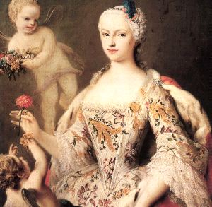
Marie Antoinette was born in 1755 November, 2. She was the daughter of the emperor of Austria. Maria was a frivolous woman, fickle and expensive tastes. At the age of twelve she knew she would be queen of France. Married in 1770 to the dauphin of France, Luis. She used to do big parties with huge banquets and many guests. It was known as the squandering of resources in France. He cared little for the misery of the people of France. She was tried by the Revolutionary Court and sentenced to death by guillotine. She attempted to flee the country with her husband Luis. They went to the prison before being beheaded. She died on October 16th, 1793.

MEMBERS:
- Marmolejo Portillo Karla Itzel
- Islas Gutiérrez Uriel
- Mendoza Alcántara Melissa
- Reyes Guido Alix

