BEAMLINE 9
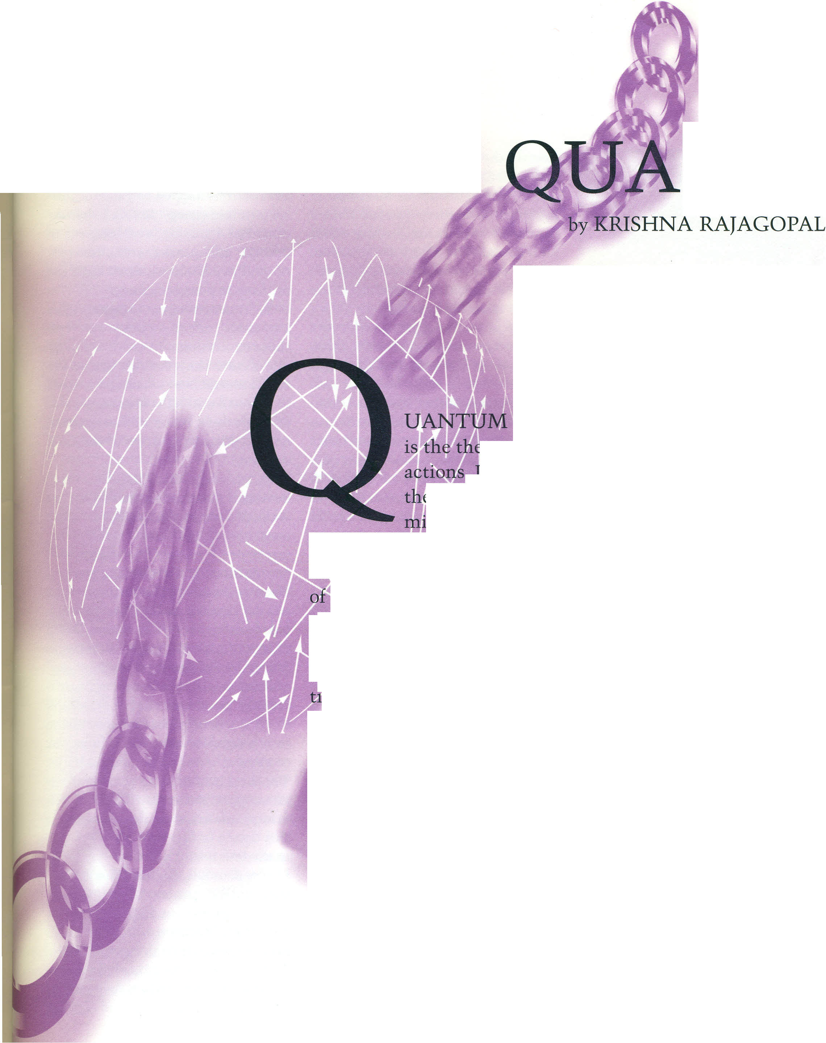
FREE THE
RKS
CHROMODYNAMICS, or QCD,
t eory of quarks and gluons and their inter-
. ts equations are simple enough to fit on
t]¡} of an envelope. After a quick glance you

g t conclude that QCD is not very different
from the t my of electricity and magnetism called quan-
tuna electf0pyna ics, or QED, which describes the behavior

Wectrons-fo x mple, those in the beams within any
television set or omputer monitor-and the photons they
interact with. The laws of QCD descrimmmmmmmmbe particles called
q arks, which are similar to electrons except that, in addi-
'on to electric charge, they carry new charges whimsically
called "colors." Their interactions involve eight new photon-
like massless particles called gluons, representing eight new
"color-electric" and "color-magnetic" fields. A glance at the
~uations of QCD suggests that they describe beams of
quarks, new color forces with macroscopic range, and gluon
lasers. This first impression would be wrong.
QCD describes protons, neutrons, pions, kaons, and 'rnany
other subatomic particles collectively known as hadrons. A
hadron has two important properties: it is "color-neutral,"
and it is much heavier than the quarks inside it. For exam-
ple, the pro ton is often described as made of two up quarks
and one down quark. Indeed, this combination of quarks has

